Risk of Injury in a Vehicle Collision Based on Environmental Factors
Michael Power
October 5, 2020
1. Introduction

Nothing beats the freedom of a car. There is no schedule to follow, no extra stops, and it can take you just about anywhere you need to go. This freedom is not with out risks though. There are so many factors that can change your normal commute into a terrible day. This project aims understand how environmental factors contribute to collisions. In order to achieve this goal, I will be analyzing a csv of Seattle car accidents in order to determine the environmental factors which contribute to more severe vehicle accidents, and ideally be able to identify conditions that make a commute particularly high risk.
2. Data acquisition and cleaning
2.1 Data Sources
Seattle’s department of Traffic Records, in conjunction with the Seattle Police Department, records and maintains a data set name "Collisions—All Years", which contains collisions provided by the Seattle Police Department from 2004 to Present which can be found here.
This Data set lists each collision as one of the following severities:

Code | Definition | Count
3 | Fatality | 349
2b | Serious Injury | 3,098
2 | Injury | 58,688
1 | Property Damage | 137,485
0 | Unknown | 21,635

The data set has 40 total columns. There are many features that describe the condition of the driver that lead to the accident, such as intoxication or speeding, as well as descriptions of the accident, such as number of people in the car. While these could certainly offer insights into education methods, my goal is to understand factors outside of the drivers control. With this in mind, I will be investigating Weather, Road conditions, and Light Conditions.
2.2 Data Cleaning
The published data is fairly clean to begin with. It has clearly defined labels and columns. After selecting the features mentioned above, as well as Latitude, Longitude, and the severity code of the accident I removed any row that had a null or unknown value. This was 15.410% of all records and the Severity Code Breakdown is as follows:
Severity Code | Difference
0 | 21,633
1 | 10,039
2 | 2,275
2b | 123
3 | 20

Finally, I added a column named ‘Injury’ which showed 1 if there was an injury of any kind (Codes 2, 2b, and 3) and 0 otherwise.
3. Methodology
3.1 Exploratory Analysis
With the goal of discovering relationships between environmental factors and accident severity, I looked at each category of each feature, as a percentage of injuries.
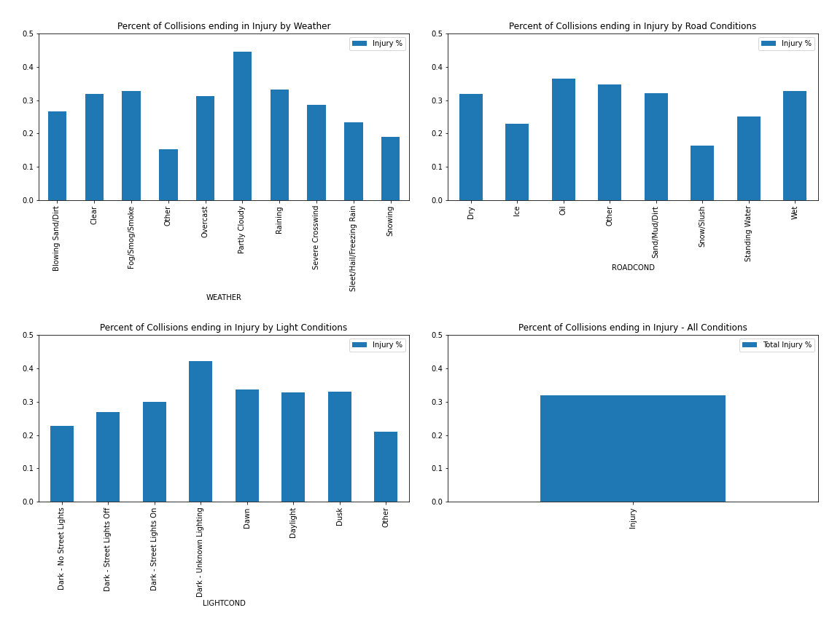
As you can see, with each category, the percentage varies. Some surprising results include the lower percentage in snow/slush on the road, as well as Partly Cloudy having the highest percentage for all weather types. With most categories within roughly 10 points of the total data set, no individual category needs to be investigated further.

I then counted each combination of the three categories and sorted them by number of incidents. I charted the top 10 and combined the other 237 combinations into an “Other” label.
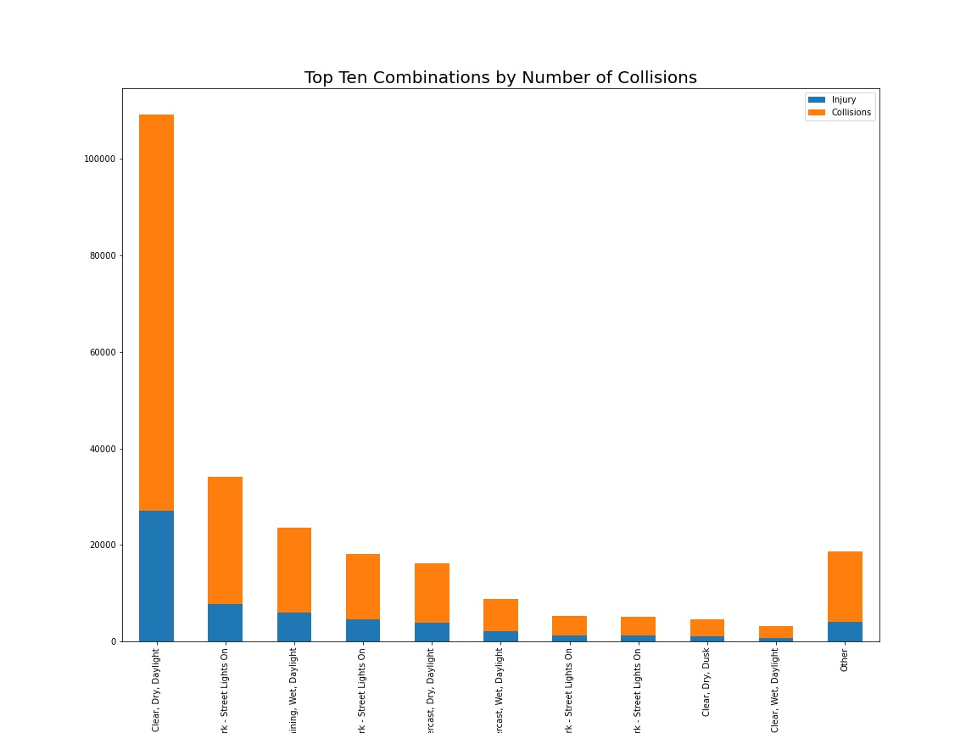
You can see that more collisions occur during clear weather, with a dry road during daylight. I would guess that the most driving happens in these conditions. Because our question takes the accident as a given, the size disparities between each group would not be expected to have a large effect on a model’s ability to asses the probability of injury.
I also graphed the grouped combinations by % of collisions resulting in an injury in a similar way to the collisions above.
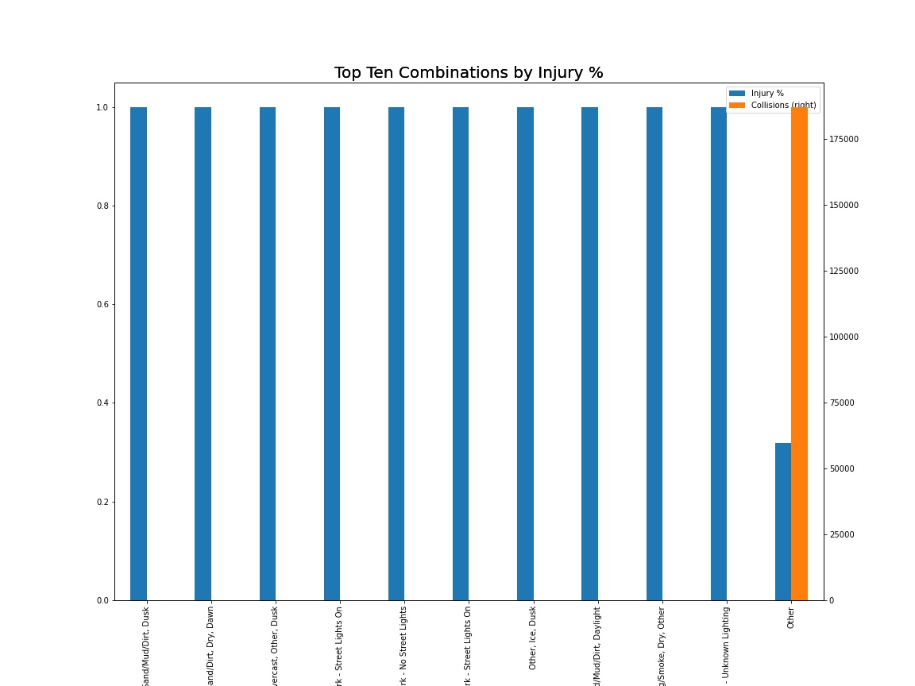
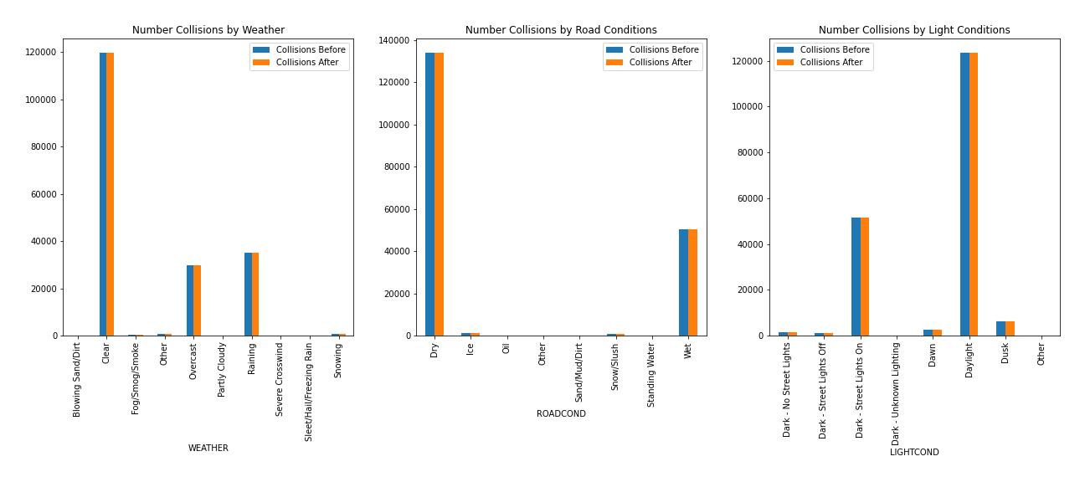
When I looked at the top 10 of these, I noticed all but the “Other” category had minimal collisions and 100% injury rate. In the case of these rarer combinations, I removed them from my training set. With such a small sample size, I would expect a model to assume these combinations at a near 100% injury rate and perform poorly on these conditions should they arise again. That being said, since each combination is valid, when assessing model performance, these incidents will be considered. I looked into how many combinations had 100% injury rate with minimal collisions, and have removed and combination with less than 5 collisions from my testing data. The Category volumes before and after are pictured below.

3.2 Regression
Using only environmental factors, I don’t expect a high predictability of injury. Instead, my goal is to use probabilities to identify which situations are most likely to result in injury. To that end, logistic regression and K-nearest neighbors will be trained on an 80/20 train/test split.
Using K-Nearest Neighbors, it is important to choose a K that generalizes well, while still getting specific enough data. Given the size of the data set, the resources needed to check every possible K was not viable, instead I stepped through potential K’s by 8.
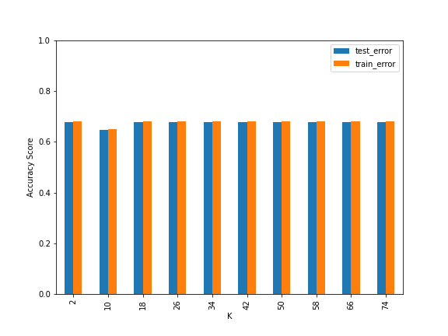

This shows that each K has a small dip in success on the test set than the train set. Given that accuracy of the model increases a small amount at 34, that is the K chosen.
Logistic Regression has some hyperparameters to consider as well. In scikit learn, the logistic Regression model offers 4 solvers. Rather forcing a decision, I check all 5, namely newton-cg, lbfgs, liblinear, sag, and saga. Below you can see that each solver performed equally well.
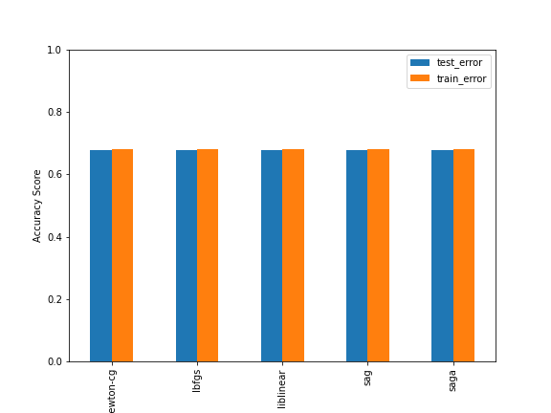

Finally, we consider which model performs better, K Nearest Neighbors with K=34 or Logistic Regression with the newton-cg solver. To evaluate these models, we will put the outliers back in, considering all collisions with know injury out comes.

Both models had the same F1-score (.551629) and Jaccard score (0). After some investigation, I found that neither model was predicting injuries. The probability of injury for both models ranged from 46.2026% and 5.542% across different environmental factors, but none predicted injury because no matter the condition, the driver is more likely to remain uninjured in the event of a collision. The chart below shows that, for the 20 most dangerous conditions, the K-Nearest Neighbors model and the Logistic Regression model have the exact same probabilities. Because of this, all further discussion will only refer to the Logistic Regression model, as it runs faster on large data sets than K=34 K-Nearest Neighbors.
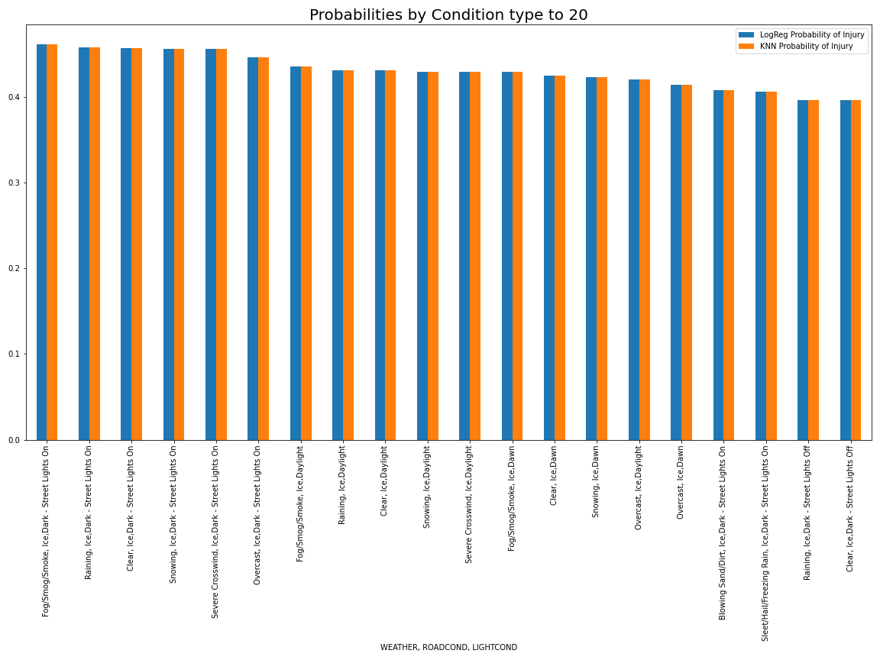

4. Results
Because the models do not predict any injuries, the best way to understand the value that the applying Logistic
Regression added is to consider the proportion of injuries in each category to the probabilities predicted by the model.
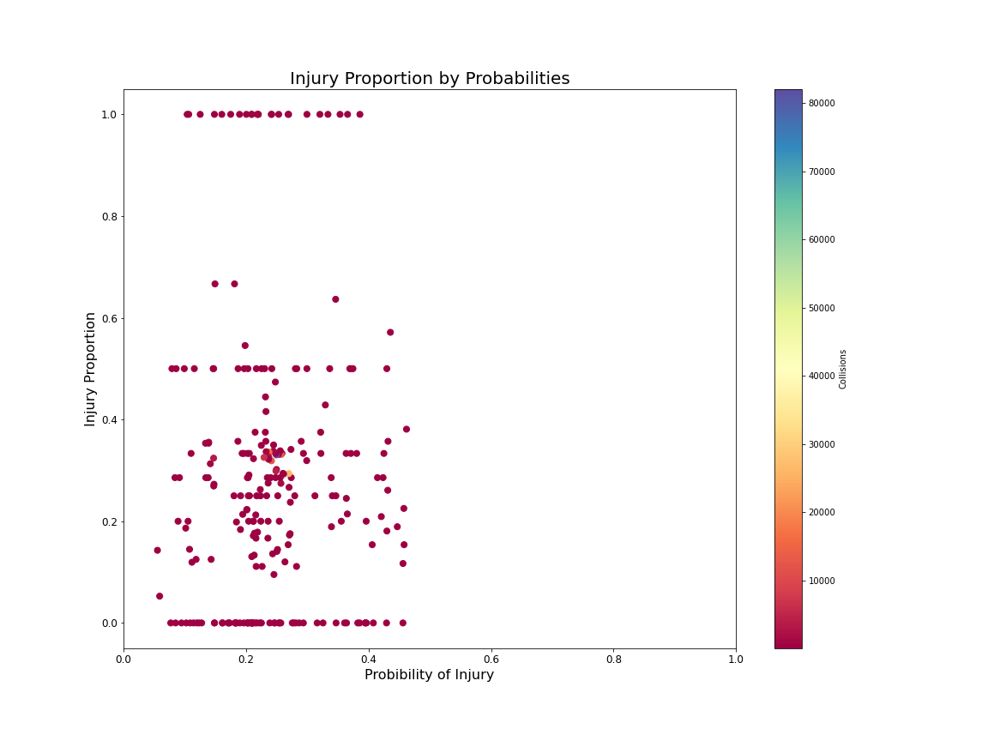
Below are the points split out by number of collisions, this gives a clearer picture of how the small subgroups have injury proportions that don not match well to the expected probabilities.

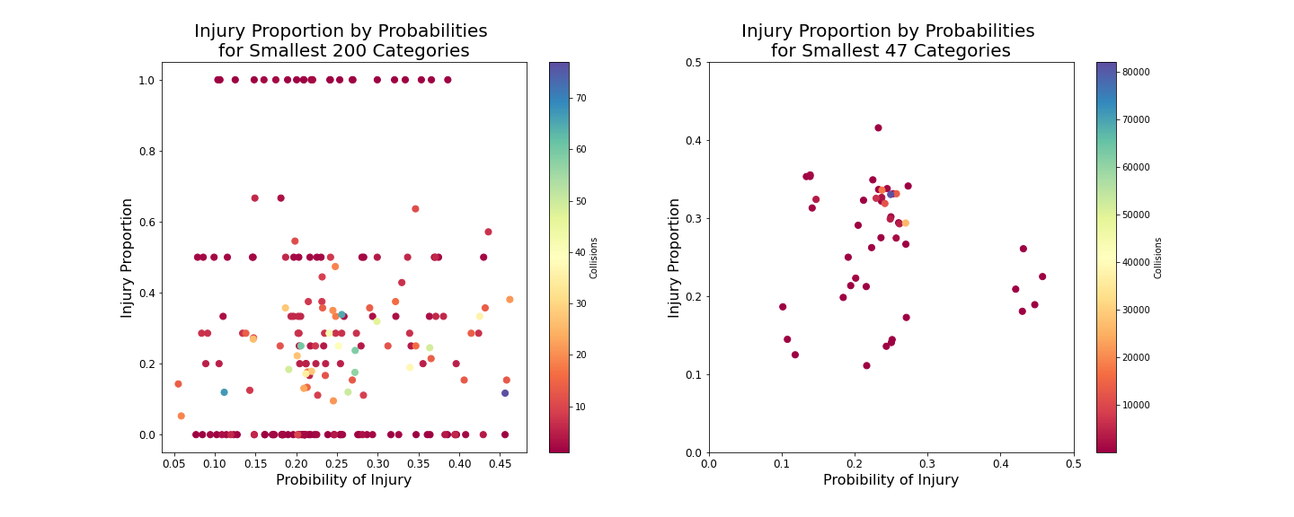
As expected, in the smallest samples, the model deviated greatly from the injury proportion, but as the samples grew larger the model’s predictions were more in line with the proportions of the data set.
5. Discussion
Some useful things to note is the limitations of three categorical variables explaining a classification when most combinations resulted in many accidents with and without injury. Removing the smallest categories in order to help the models generalize resulted in many of the variable combinations differing drastically in probability and proportion. I would venture to guess that if the sample sizes increased, the proportions would move toward the probabilities. This especially true for any of the combinations with 0% or 100% of collisions resulting in injury.
Also worth noting, Logistic Regression and K-Nearest Neighbors were equally effective in understanding the data but I would recommend avoiding K-Nearest Neighbors for large data sets, as the processing time to train and predict was much higher than it was for Logistic Regression.
6. Conclusion
Analyzing only weather, road conditions, and light conditions, can not predict an injury, but it does show which situations may be more dangerous, when considering one’s own safety. Particularly, icy conditions at night seemed to be the most likely to result in injury. A future analysis might take into account driver states, such as intoxication, or driver choices like speeding. These things are more easily changed by the individual and can help an average driver.

